Lab description:

In this lab, we are supposed to display the second byte in LED. To be specific, the process can be separated into 9 parts:

1. Select the correct version of drivers according to your computer. The software in your kit is not completed; some of them are rather old. So you may need to find it online by yourself. And if you use virtual machine, this step is crucial. Never underestimate this step!

The drivers includes:

* USB blaster driver
* YAMAHA USB-MIDI driver

1. Install all the required software. The set of software includes:

* Quartus II 9.1 (included in kit)
* MIDI-OX (included in kit)
* Logic analyzer (available in [www.saleae.com](http://www.saleae.com))

1. Initiate your project. Select the correct CPLD (EPM7064SLC44-10), and leave everything else as default.
2. Start coding and debug one block by one block. The recommended sequence is:
   1. Use frequency divider to match frequency of signal, and synchronize your “local_clk” with signal.
   2. Temporally store the input signal.
   3. Use state machine to decide whether this frame is the second.
   4. Display in your LED.
3. Use function simulation and timing simulation to verify your code. Before simulation, remember to assign pin to your input and output, set un-used input into tri state to avoid further accident, and generate netlist.(You can also use Ctrl + Shift + K to do this all at once. )
4. Wire your circuit! Carefully wire your circuit!! Very carefully wire your circuit!!! There are several things need attention:
   1. The 1st pin in 10-pin resistor bar is marked by a dark dot.
   2. The 1st pin in programmer sock is market by a triangular.
   3. Don’t use the grounded LED.
5. Program CPLD. To do this, first make sure USB driver blast is properly installed, and select it (refer to video when need). Check the first two options and click “start”.

Note: before disconnection, discharge breadboard first, unplug programmer from programmer socket, and unplug USB from your computer. Always follow the three steps; otherwise it may ruin the whole thing.

1. Setup MIDI-OX. Make sure you have installed the driver and plug in the YAMAHA USB-MIDI cable. Open the software, and select YAMAHA USB-MIDI cable. Click the keyboard icon in control panel, so that you can use keyboard as input.
2. Open Logic analyzer software and connect the analyzer to your computer. Make the software indicates “Connected”. Connect probes to desired wires, choose a signal as trigger, and click start before sending MIDI signal in MIDI-OX.

Note: make sure the sample rate is larger than 8MHz to avoid alias. The official manual recommends 16MHz, but this setting may cause software crushed.

Expected result:

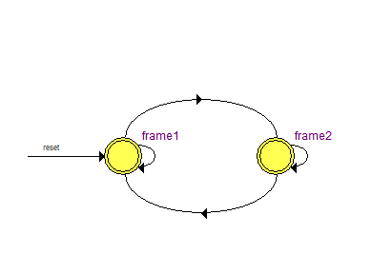

Figure 1 state machine

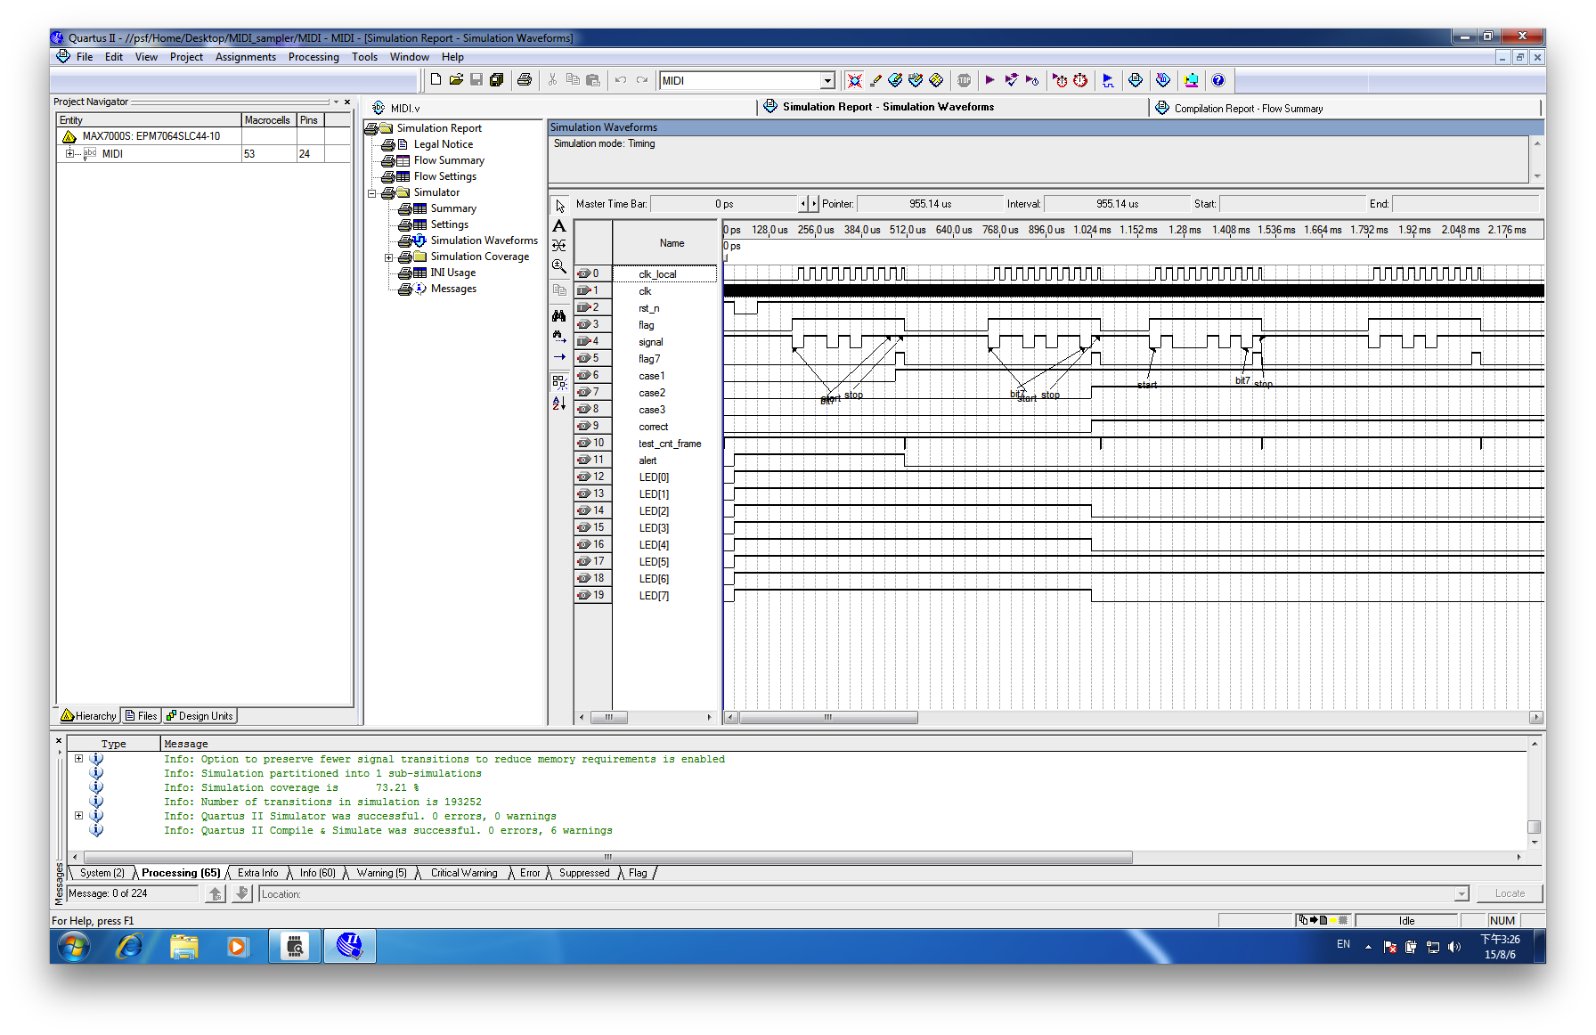

Figure 2 timing simulation result

Common Questions:

1. Cannot detect YAMAHA MIDI-USB cable/Logic analyzer.

Solution: Please double-check your driver. If you use virtual machine, make sure it is Windows connect them rather than some other system.

1. Cannot install drivers.

Solution: make sure the driver matches with your CPU. And, in addition, UMASS refuses to give the access for MIDIOX, so you probably need to download it from other places.

1. Cannot send MIDI signal to board.

Solution: First check whether the YAMAHA USB-MIDI is in your devices list, and you also have selected it. A message said “2 Outputs” will shows in your bottom left. And then make sure the piano icon has been activated. It will flash if so. If it still not works, check circuit.

1. Logic analyzer is unstable.

Solution: Fasten sample rate 2 times faster then the fastest signal. Check probe is not contacted with other wires. Make sure your trigger is correct. If still not working, change an analyzer.

1. Can not program CPLD.

Solution: Make sure board is powered up, and hardware is setup. And then make sure you have checked “Program/Configure”. If you can not see the “.pof ” file, make sure you have complied it.